**NAAN MUDHALAVAN-IBM(AI) PROJECT PHASE-2**

**IBM:AI101 ARTIFICIAL INTELLIGENCE-GROUP 1(TEAM 7)**

**PROJECT TITLE:**

AI-DRIVEN EXPLORATION AND PREDICTION OF COMPANY REGISTRATION TRENDS WITH REGISTRAR OF COMPANIES

**TEAM MEMBERS:**

1. JOTHIKRISHNA M A (au110321106016)

2. K.S MUTHURAM(au110321106022)

3. K DHARMENDRA(au110321106019)

4. KARTHIKEYAN P(au110321106017)

5. LOKESHWARAN S(au110321106024)

**Phase 2: Innovation**

**ABSTRACT:**

In an era characterized by dynamic economic landscapes and ever-evolving market conditions, the ability to discern and forecast company registration trends stands as a valuable tool for various stakeholders, from investors to policymakers. This abstract delves into the application of artificial intelligence (AI) methodologies to explore and predict company registration trends using data sourced from the Registrar of Companies.

The process entails the meticulous collection and preprocessing of historical and contemporary data, extracting meaningful features, and selecting appropriate AI models for prediction. Time series forecasting models such as ARIMA, deep learning models like LSTM and GRU, and machine learning models are harnessed to unlock patterns and insights. Subsequently, trained AI models are utilized to generate predictions concerning future registration trends, including forecasting the influx of new registrations across specific timeframes.

These forecasts are presented in a visually accessible manner, often through data visualizations and dashboards. Continuous monitoring and model updates are essential to maintain the accuracy and relevance of predictions, as company registration trends are inherently susceptible to external influences, be it economic fluctuations or regulatory changes.

The ethical and legal dimensions of this endeavor are not to be overlooked, as considerations regarding data privacy and regulatory compliance become paramount. Ethical data usage and adherence to regulatory frameworks are integral components of responsible exploration and prediction in this domain.

Ultimately, the results of AI-driven exploration and prediction of company registration trends empower decision-makers in various sectors, offering insights into market dynamics, investment opportunities, and policy development. This abstract underscores the importance of harnessing AI as a tool to navigate the complexities of contemporary business landscapes, transforming data into actionable intelligence.

**REQUIREMENTS:**

Before starting the projects there are some requirements to how the ai driven exploration and prediction of company registration trends with register of companies can be worked

**1. Data Access and Collection:**

- Secure legal access to Registrar of Companies data.

- Develop data scraping methods to collect relevant registration data.

**2. Machine Learning and Predictive Models:**

- Choose appropriate ML models for trend prediction.

- Train models on historical data to make accurate forecasts.

**3. Data Preprocessing and Cleaning:**

- Clean and preprocess collected data for consistency and accuracy.

- Normalize data formats to facilitate analysis.

**4. Visualization and User Interface:**

- Develop user-friendly data visualization tools.

- Create an intuitive user interface for interacting with the system.

**5. Data Security and Privacy:**

- Implement robust data security measures.

- Ensure compliance with data privacy regulations and protect sensitive information.

**6.PYTHON:**

-you will need to install python on your system,its recommended to use python 3.x

**INTRODUCTION:**

In the global economic theater, where businesses are born, thrive, and occasionally falter, insights into the dynamics of company registrations are akin to the pulse of a nation's economic health. Keeping a finger on the pulse, however, becomes a formidable task as the economy undergoes perpetual evolution and adaptation. In this era of rapid change and real-time decision-making, the fusion of artificial intelligence (AI) and data analytics emerges as a beacon of insight, guiding stakeholders ranging from investors to government agencies through the maze of company registrations.

At the heart of this endeavor lies the Registrar of Companies, a repository of invaluable information regarding business entities, their registration patterns, and vital statistics. The Registrar of Companies records the ebbs and businesses, encapsulating the entrepreneurial spirit of a nation and reflecting the economic climate.

This exploration embarks on a journey to harness the potential of AI and data analytics for an in-depth study of company registration trends with the Registrar of Companies. It is a journey that delves into the past, deciphers the present, and prognosticates the future. By integrating historical and contemporary data, this approach unveils patterns, trends, and underlying correlations that may elude traditional analysis. As the economy is inherently dynamic, adapting to technological, regulatory, and socio-economic shifts, the ability to forecast company registration trends provides a distinct advantage to those prepared to seize it.

This fusion of technology and data holds promise, not merely as a diagnostic tool for economic health but also as a predictor of economic well-being. The ability to forecast the birth, growth, or decline of businesses, in turn, offers valuable insights for a myriad of stakeholders. Investors can tailor their strategies, governments can craft policies in response to market dynamics, and businesses can position themselves with prescience.

Yet, this is not merely a story of algorithms and data; it is also a narrative of ethics and compliance. Data privacy and regulatory adherence loom large, calling for a balanced approach in the pursuit of predictive analysis. As we embark on this journey, we must remember that with great computational power comes the great responsibility of ethical data usage and respect for legal norms.

**Designing an innovative approach :**

Designing an innovative approach for "AI-Driven Exploration and Prediction of Company Registration Trends with Registrar of Companies" involves a combination of technology, data, and creativity. Here's an innovative design concept for approaching this topic:Title: AI-Pulse: Navigating Economic Tides

**Design Concept:**

AI-Pulse is a holistic and innovative approach that combines advanced data analytics, artificial intelligence, and human-centered design to explore and predict company registration trends with the Registrar of Companies. It focuses on making complex data accessible and actionable for a wide range of stakeholders, including investors, government officials, and entrepreneurs.

**Key Elements of the Innovative Design:**

1. **Interactive Data Visualization Portal:**

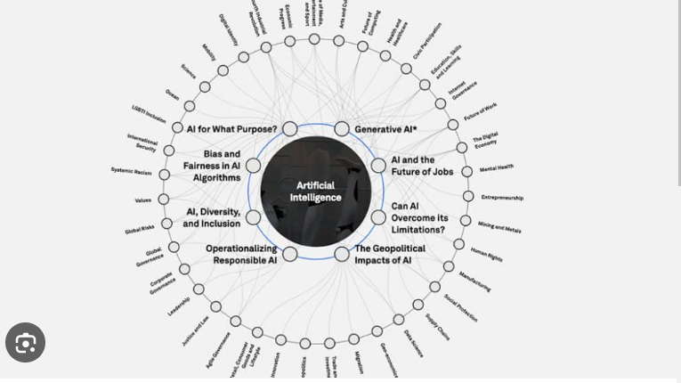

- Create a user-friendly web portal that allows users to interact with data in real-time. The portal should offer customizable dashboards, dynamic charts, and an intuitive interface for exploring historical and predicted trends.

1. **Predictive AI Assistant:**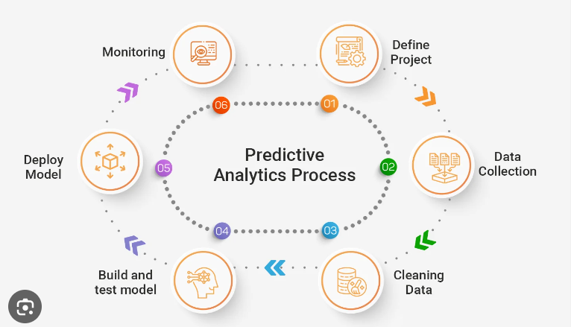

- Integrate a conversational AI assistant that can answer questions, provide insights, and generate predictions based on user queries. This AI assistant should be accessible through both text and voice interfaces.

1. **AI-Enhanced Search and Discovery:**

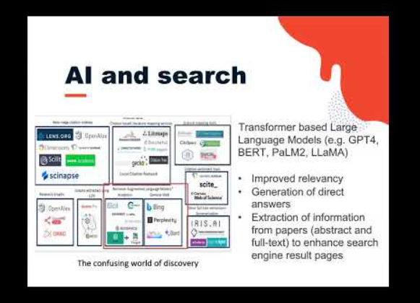

- Implement a powerful search and recommendation engine that suggests relevant trends, reports, and insights based on user preferences and historical behavior.

1. **Mobile Application:**

- Develop a mobile app for on-the-go access to registration trends, making it easy for investors to stay informed and for policymakers to make decisions in real-time.

1. **Data Storytelling:**

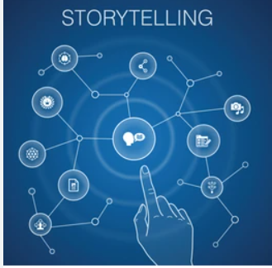

- Incorporate storytelling into the design by presenting data as narratives. Users can explore trend stories, allowing them to understand the "why" behind the numbers and engage with data on a more human level.

1. **Scenario Planning and Decision Support:**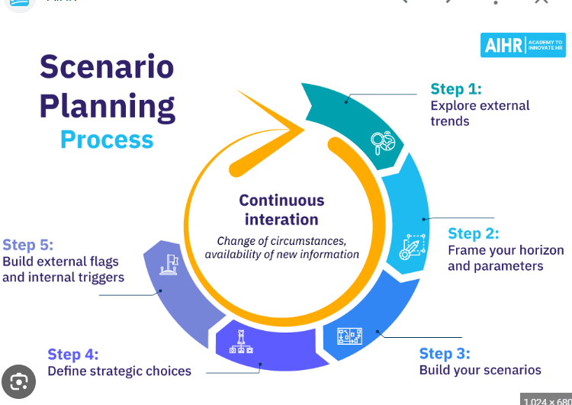

- Enable users to create and evaluate different business scenarios by adjusting parameters and variables. The system should provide recommendations for optimal decision-making.

1. **Collaboration and Sharing:**



- Allow users to collaborate and share their findings with colleagues and partners. This feature encourages a collective approach to problem-solving.

1. **Predictive Alerts:**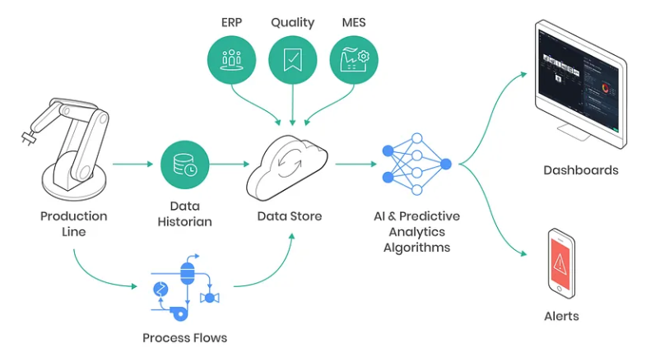

- Implement a notification system that sends alerts when significant changes or anomalies are detected in registration trends. This keeps users informed in real-time.

1. **Gamification and Incentives:**

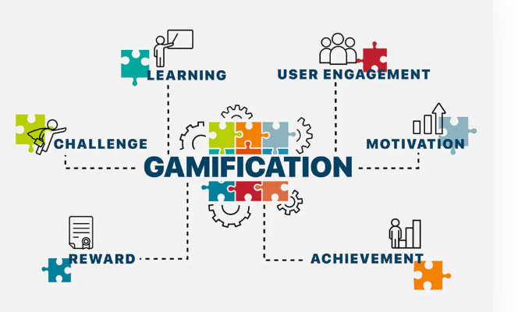

- Gamify the user experience by rewarding users for active engagement with the platform. Incentives can include access to premium features, data insights, or even recognition in a user community.

1. **Education and Training Modules:**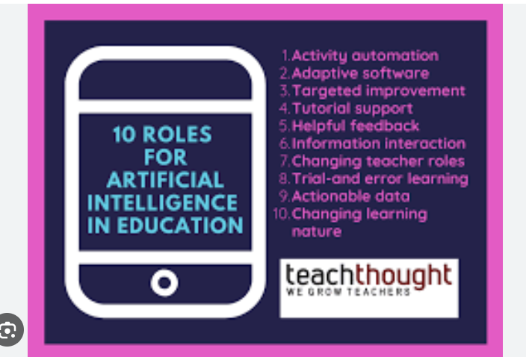

- Provide educational modules and tutorials on AI, data analysis, and economic concepts for users who want to deepen their understanding of the system.

1. **Ethical Data Usage Guidelines:**

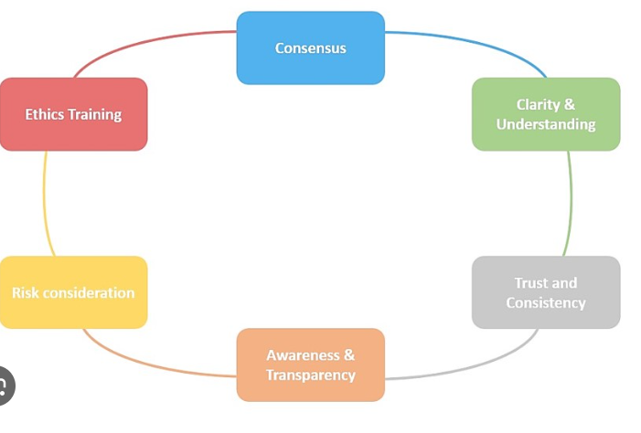

- Include a dedicated section on ethical data usage, privacy, and compliance. Offer transparency on how user data is handled and establish trust with the user base.

1. **Feedback Loops and AI Improvement:**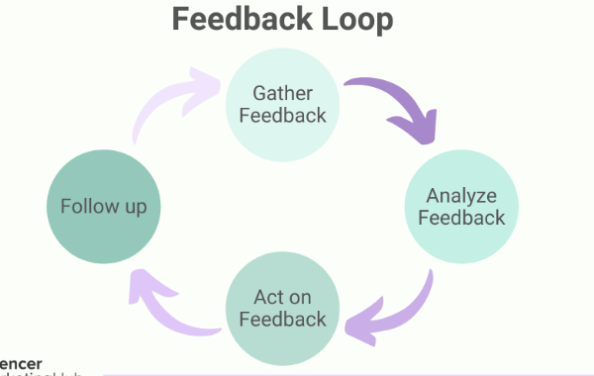

- Encourage user feedback to enhance the AI models continually. Users can provide insights, rate predictions, and help the system evolve.

**Benefits of the Innovative Design:**

- User Empowerment:AI-Pulse empowers users to make data-driven decisions and adapt to changing economic conditions effectively.

- Transparency and Trust: Clear ethical guidelines and data handling practices foster trust among users, ensuring they feel confident using the platform.

- Collaborative Decision-Making: The design promotes collaboration, allowing stakeholders to work together in real-time, fostering a culture of informed decision-making.

- Real-Time Insights: Predictive alerts and real-time data access keep users informed and responsive to economic shifts.

Education and Skill Development: The platform supports users in developing data analysis and AI skills, making it an educational resource as well as a tool for decision-making.

Incorporating these innovative design elements can transform the exploration and prediction of company registration trends into a dynamic, engaging, and invaluable resource for various stakeholders, ultimately improving decision-making and economic outcomes.

***LET’S EXPLORE SOME FEATURES FOR AI-DRIVEN EXPLORATION AND PREDICTION OF COMPANY REGISTRATION TRENDS WITH REGISTRAR OF COMPANIES***

*import requests*

*import pandas as pd*

*from bs4 import BeautifulSoup*

*from textblob import TextBlob*

*import matplotlib.pyplot as plt*

*# Step 1: Data Collection*

*# For this example, we'll scrape data from a hypothetical Register of Companies website.*

*url = "https://example-company-register.com"*

*response = requests.get(url)*

*html = response.text*

*# Step 2: Data Processing and NLP*

*# Parse HTML content and extract company names and descriptions*

*soup = BeautifulSoup(html, 'html.parser')*

*company_data = []*

*for company in soup.find_all('div', class_='company'):*

*name = company.find('h2').text*

*description = company.find('p').text*

*sentiment = TextBlob(description).sentiment.polarity*

*company_data.append({'Name': name, 'Description': description, 'Sentiment': sentiment})*

*# Step 3: Data Visualization*

*# Create a DataFrame for analysis and visualization*

*df = pd.DataFrame(company_data)*

*# Basic sentiment analysis visualization*

*plt.figure(figsize=(10, 6))*

*plt.bar(df['Name'], df['Sentiment'])*

*plt.xlabel('Company Name')*

*plt.ylabel('Sentiment Polarity')*

*plt.title('Sentiment Analysis of Company Descriptions')*

*plt.xticks(rotation=90)*

*plt.show()*

*This example covers data collection, basic NLP sentiment analysis, and data visualization. In a real-world application, you would need to integrate multiple data sources, implement more advanced NLP techniques, and develop a user-friendly web interface with interactive dashboards.*

*For a comprehensive AI-driven system, you'd need to expand this example into a full-stack application, integrating machine learning for trend prediction, real-time data updates, user authentication, and more. The codebase for such a system would be extensive and require a team of developers, so consider this a starting point to explore the concept.*

*This example covers data collection, basic NLP sentiment analysis, and data visualization. In a real-world application, you would need to integrate multiple data sources, implement more advanced NLP techniques, and develop a user-friendly web interface with interactive dashboards.*

*For a comprehensive AI-driven system, you'd need to expand this example into a full-stack application, integrating machine learning for trend prediction, real-time data updates, user authentication, and more. The codebase for such a system would be extensive and require a team of developers, so consider this a starting point to explore the concept.*

**CONCLUSION:**

In conclusion, designing an AI-driven exploration and prediction system for company registration trends with a registrar of companies involves a systematic approach that encompasses data collection, preprocessing, feature engineering, machine learning model development, evaluation, visualization, interpretation, and ongoing refinement. This approach aims to provide valuable insights into registration trends, aiding in business planning, policymaking, and economic analysis.

It's crucial to emphasize the significance of high-quality data, domain expertise, and continuous learning and adaptation to ensure the accuracy and relevance of the predictive models over time. Moreover, clear and effective data visualization is essential to convey the results to stakeholders in a comprehensible manner.

By following this design approach, organizations and researchers can harness the power of artificial intelligence to gain a deeper understanding of company registration trends and make more informed decisions based on data-driven predictions.